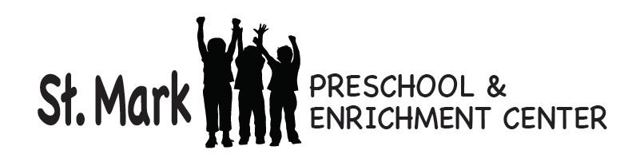
October 20, 2017

Dear Parents,
Many thanks to all of you who were chaperones on our Metra train trip to Norwood Park! We couldn’t have done it without you. What a fabulous day! Although it took a while, we finally were able to enjoy the trip and the perfect weather.
Thank you to all who supported our Club’s Choice Fundraiser. Money earned on our fundraisers are used towards preschool improvements.
The 4’s have been busy getting ready for Halloween. We have created many Halloween art projects including a Five Little Pumpkin picture, Frankenstein monsters, and sparkly witches’ hats. Be sure to check out our classroom and the hallway once we are fully decorated. Halloween math involving graphing and counting has kept us busy. We have also learned about the life cycle of a pumpkin.
Monday we had chapel. All families are welcome to attend chapel which takes place monthly in the church at 11:00. Pastor Christie or Mr. Webb leads chapel. Usually a Bible story is read which is related to our unit of study. Occasionally, a craft or activity is done, a song is sung, and we always end with a prayer. During this week’s chapel we talked about baptism.
We want to enjoy the awesome “Fall” weather as much as we can. We will go outside as long as the weather permits. Please have your child dress for these outdoor activities with coats, hats, and gloves if necessary. And as always, gym shoes are the best footwear for school, playground, and the gym. Please take this opportunity to check your child’s extra clothes bin to make sure there are clothes in the bin and that the clothing is appropriate for the weather.
The children are already talking about what they want to be for Halloween. In deciding on a costume, please know that some children at this age have a hard time distinguishing real from pretend. Because of that we want to discourage your child from wearing masks or face paint. Also, the children will be walking up and down stairs to go trick or treating in the offices, so be sure their costume will allow them to do that. We invite you to hear us sing our Halloween songs on Monday, 10/30 at 11:15am in the block room.
Enjoy the fall days!
Sincerely,

Barb

