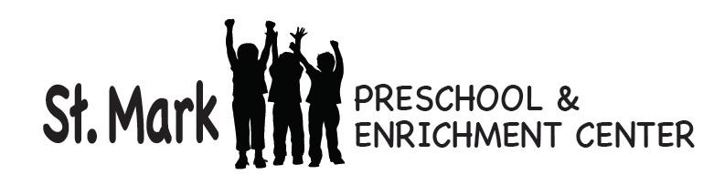
October 19, 2017
Dear Parents,
We have been exploring the fall season. We learned that autumn is a time when leaves change color and fall off the trees. The beauty and magic of fall! Check out the squirrels and nuts hanging in the hallway. Can you find your child’s handprints? We have also been getting our school ready for Halloween. We have already made pumpkins and scarecrows to decorate the classroom.
Tuesday was chapel day. At our chapel time, the children meet in the church sanctuary. Pastor Christie and/or Mr. Webb give a short message, lead us in prayer, and sing a song or two. During this week’s chapel we talked about baptism. Families are welcome to sit in the pews and join us for our chapel time.
We want to enjoy the awesome “Fall” environment as much as we can. We will go outside as long as the weather permits. Please have your child dress for these outdoor activities with coats, hats, and gloves if necessary. And as always, gym shoes are the best footwear for school, playground, and gym. Please take this time to check your child’s extra clothes bin in their cubby to make sure there are clothes in there and that they are appropriate for the weather.
The children are already talking about what they want to be for Halloween. In deciding on a costume, please know that some children at this age have a hard time distinguishing real from pretend. Because of that we want to discourage your child from wearing masks or face paint. Also, the children will be walking up and down stairs to go trick or treating in the offices, so be sure their costume will allow them to do that. The party for the threes will take place on Tuesday, October 31st. Family members are invited to attend the last 15 minutes of class from 11:15-11:30 to hear us sing our Halloween songs in the block room.
Thank you for supporting the Club’s Choice Fundraiser. The funds we raise this year will go towards preschool improvements.
Looking ahead to November, St. Mark will be closed on Thursday, November 23rd and Friday, November 24th for Thanksgiving. We have regular classes on Monday and Tuesday of Thanksgiving week. Wednesday, November 22nd we are open for child care only. Please let me or your teacher know if you will be attending classes that week so we can order an adequate amount of lunches. You can email me at bzediker@stmarkmp.org.
Happy Fall!

Sincerely,

Barb

