St. Mark Kindergarten Enrichment News
October 19, 2017
This week in our kindergarten enrichment class we continued our study of magnets. We made 2 different refrigerator magnets. Next week we begin the process of creating our own board games. When they are complete, we will use a magnet to move magnetic pieces around the board. Be sure to check out our scientific artwork in the hall. We used results from previous experiments to separate magnetic and non-magnetic items.
Our class is reading The Magic School Bus: Amazing Magnets. The children in Ms. Frizzle’s class are trying to win a contest by answering questions about magnets. If our class was in the story, we might win that contest because we already know a lot about magnets.
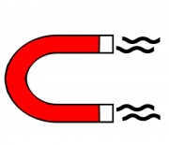

Reminder:
We still go outside during every class. It helps us get the wiggles out and gets us ready to learn. Please make sure your child has proper outerwear and footwear as the weather is gets cooler.
Our Halloween Parties are Tuesday, October 31st.
Join us for singing at 11:15 or 2:45 if you are able.
Remember: No masks.

